SeaBASS Submission Checklist:
Chromophoric Dissolved Organic Matter (CDOM)

Experiment Name: NES-LTER (Northeast Shelf Long Term Ecological Research)
______________________________________________________________________Cruise Name: all cruises
______________________________________________________________________

I. SAMPLE COLLECTION METHODS
1) How were the samples collected in the field? (e.g. Niskin bottle, surface pump, bucket) If applicable, were samples taken on upcast or downcast?
Samples were collected by CTD rosette Niskin bottle on the upcast if depth is greater than 0m, or by surface bucket if depth equals zero. Water was collected in 2 clean, acid washed 4oz amber glass bottles with Teflon lined caps. Collection bottlers were triple rinsed and then filled and brought into lab to filter.
2) Where were they collected (coastal, offshore, estuarine, etc.) and at what general depths?
Coastal – samples were collected at stations across the northeast shelf along a transect line of 70 deg 53’ W - extending ~85 nm south from Martha’s Vineyard and also at Martha’s Vineyard Coastal Observatory. Site information and a link to a list of standard stations can be found here: https://nes-lter.whoi.edu/about/#where
3) How were samples filtered? (e.g., vacuum pump, peristaltic, syringe, vacuum jar, etc.)
Samples were filtering using an all- glass flask and filtration apparatus (e.g., Millipore Corp.) with a 0.22 µm polycarbonate filter. Glassware should be previously cleaned with 2% Mmicro-90 (Cole Parmer), [H1.1]10% HCl, and Milli-Q water (Millipore). See photo below. Filtration glassware and sample bottle were rinsed twice with ~40ml of filtrate. After rinsing, the sample bottle was filled and refrigerated until analysis.
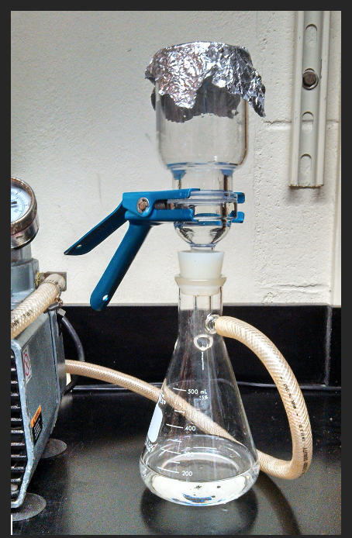
4) What type of filter and pore size was used to filter? (e.g. flat disk, capsule, syringe filter, etc.)
A flat disk 47mm 0.22 µm polycarbonate filter was used to filter samples after collection. If sampled needed additional filtering during analysis, a Sterivex 0.22um polyethersulfone membrane filter unit was used (Millipore Cat No: SVGP01050)
5) Approximately how long after collection were the water samples filtered?
~20-60 min after collection
6) Approximately how long were the filtered samples stored before analysis?
Typically 6 months. Each seabass data file notes the date of analysis in the header comments.
7) Were samples stored WITHOUT acidification? (Note: Acidification can alter the optical properties of samples.)
WITHOUT acidification
8) Were samples kept refrigerated after filtration and kept between 4-10C?
Refrigerated after filtration at ~4C.
9) Were samples stored in combusted amber glass bottles? ( Note: Storing samples in plastic bottle can lead to CDOM leaching from the plastic into the samples. )
Samples were stored in clean, 2%micro washed, then acid washed 4oz amber glass bottles with Teflon lined caps. Bottles were not combusted.

II. Sample Analysis Methods
1) List instrument manufacturer and model
Shimadzu UV-2600i, S/N: A12595900733
2) What type of spectrophotometer was used (dual or single beam, waveguide, integrating sphere, etc.)? For benchtop specs, what was the cuvette size (1, 5, or 10 cm)? For Waveguides, what was the effective pathlength of the instrument either measured by the manufacturer or by the researcher?
Dual beam spectrophotometer with standard optics and cylindrical quartz cuvettes, type 34, path length 10mm, match code 6 (Starna Cells, Inc.).
3) Provide instrument settings
integration time: NA
scan speed: “slow speed”
slit width: 5.00 nm
smoothing: No
wavelength range and increment: 200-900 nm with 1 nm resolution
other: Lamp UV & Lamp Vis: ON;
Light Source Switch Wavelength: 319 nm
S/R Switch: Standard
4) Were the samples re-filtered before the spectrophotometric analysis?
Samples were re-filtered prior to analysis if there were visible particles in the sample or if the first sample run curve looked suspicious. Otherwise samples were not re-filtered
5) Was a solution of Suwanee River Fulvic Acid (SRFA) measured during the analysis? What was the concentration of the solution? See Mannino et al. 2019 for more information.
No
III. Data Analysis Methods:
1) If there were multiple scans: how many and were they averaged? If so, remember to provide the standard error or deviation values, and use the header �bincount� to indicate the number of measurements (n) averaged. [PI1](e.g., /bincount=ag:3)
Each sample is a single scan. If the first scan looked suspicious, a second scan was performed. It was then assessed which scan was appropriate to use and the additional scan(s) was discarded.
2) Did you collect replicates? How many? Please do not average the replicates and submit one per SeaBASS file.
No replicates were collected.
3) Was decadic or Naperian absorption reported? The raw absorbance values should always be reported with the data.
No
4) What type of corrections were applied to the data? If the data was null corrected, the method should be described containing information on the wavelength region the null correction was calculated from and its value. The absorption coefficients can be null corrected; however, the raw absorbance values should be reported without the null correction applied. See REPORTING GUIDELINES below for how to report null correction.
No corrections were done
5) If the instrument baseline drifted during the analysis and a final MilliQ scan was used to correct the data, this should be documented and reported. The information provided should allow data users to take the raw data scans and calculate the final absorption reported by the user.
Not final correction was applied.
6) If the spectral slope is reported, what was the range and method for calculating the slope? Was it a linear fit to log transformed data or a nonlinear exponential fitting routine? The absorption can be null corrected, however, the raw absorbance values should be reported without the null correction applied.
CLIVAR says: The spectral slope was calculated over the range 300-600nm and was carried out using a nonlinear iterative fitting routine using the Matlab function nlinfit. This value was reported in the header of each seabass file.
No spectra slope is reported

IV. (If applicable) Waveguide-specific Reporting:
1. The salinity correction method should be well documented. What type of salt solution(s) were used for the correction (artificial sea water, NACL, etc.)? Was the sample measured with a matched salinity reference or was MilliQ used as a reference and the sample was later corrected with a salt solution spectra or curve?
NA
2. Scan settings should be reported (integration time, accumulations per scan, smoothing, etc.)
NA
3. How many scans per sample, and were the average and standard deviation reported?
NA

V. (Do not fill in) Reporting Guidelines & Reminders:
1. The entire raw scan of absorbance should be reported for each discrete measurement. If multiple scans were measured, the average absorbance can be reported along with the standard deviation.
2. The absorption coefficient may be reported after null correction, smoothing, truncated wavelengths, etc. have been applied. However, this or another documentation file should be provided describing the methods for collection, filtration, analysis, etc. steps needed to calculate the final absorption spectra.
3. If you performed a null correction, or wish to report a calculated spectral slope, is helpful to include the calculated values in the metadata header (and include more details on how they were calculated in your documentation.)
- • If a null correction was applied, use the form: /null_correction=ag:0.0076.
- • To report “s_ag”, include the wavelength range used for the calculation as part of the name, e.g., “s_ag_300nmmin_600nmmax”. If only 1 s_ag is applicable to the entire data file, then store the information in the metadata headers using the form “/s_ag=s_ag_#nmmin_#nmmax:VALUE”, replacing # and VALUE with the relevant numbers.
4. Typical fields in a CDOM spectra file include: wavelength, abs_ag, abs_ag_sd, ag

